Basic Client Information
Full Name | ........................................... | Gender | ...................................
Age | ................................................ | Date | .......................................
Symptoms
1. Please rate your symptoms during the last week by placing a tick in the box that best describes each symptom.
(please tick none if you do not have this symptom)
 | No symptoms  or very rarely | Occasional  mild symptoms | Frequent symptoms that  affect some social activities | Continuous symptoms that  affect most social activities
 | None | Mild | Moderate | Severe
Abdominal pain/discomfort | ☐ | ☐ | ☐ | ☐
Abdominal bloating/distension | ☐ | ☐ | ☐ | ☐
Increased flatulence/wind | ☐ | ☐ | ☐ | ☐
Belching or burping | ☐ | ☐ | ☐ | ☐
Stomach/abdominal gurgling | ☐ | ☐ | ☐ | ☐
Urgency to open bowels | ☐ | ☐ | ☐ | ☐
Incomplete evacuation  (feeling of inability to pass all stool) | ☐ | ☐ | ☐ | ☐
Nausea | ☐ | ☐ | ☐ | ☐
Heartburn | ☐ | ☐ | ☐ | ☐
Acid regurgitation | ☐ | ☐ | ☐ | ☐
Tiredness/lethargy | ☐ | ☐ | ☐ | ☐

 | Symptom Evaluation Form  Please complete this form prior to your appointment and return it via email or bring it with you to your consultation at Ballina Primary Care Centre. | Mary Bourke Dietitian  Ballina Primary Care Centre  Ballina, Co. Mayo  087 412 8948  info@marybourkedietitian.ie
Bowel Action
2. Currently, how often do you pass a bowel action? (please tick one box)
Once a week | ☐ | Once a day | ☐
Once every 4-6 days | ☐ | 2-3 times a day | ☐
Once every 2-3 days | ☐ | 4-6 times a day | ☐
 |  | 7 or more times a day | ☐
3. Do you currently have satisfactory relief of your gut symptoms? (tick one)
Yes | ☐ | No | ☐
4. Please tick the box that best describes your current stool:
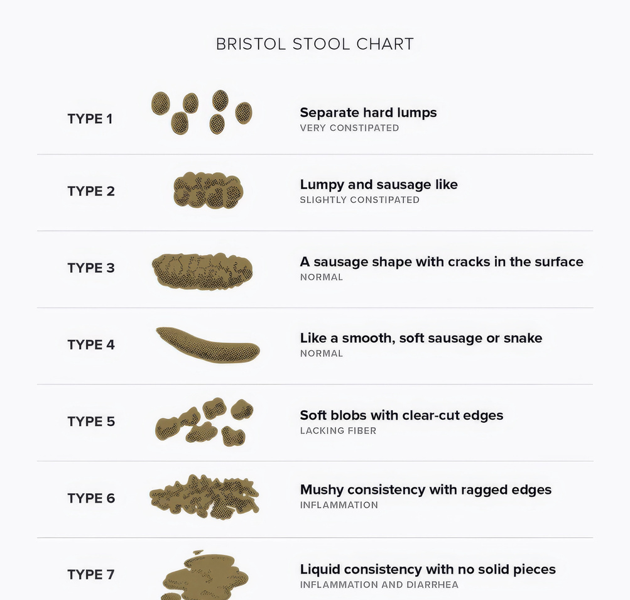 | ☐  ☐  ☐  ☐  ☐  ☐  ☐
Produced by Department of Gastroenterology & Department of Nutrition & Dietetics, Guy's and St Thomas' NHS Foundation Trust; Nutritional Sciences Division, King's College London, London UK

